Slide lock Pansy Card
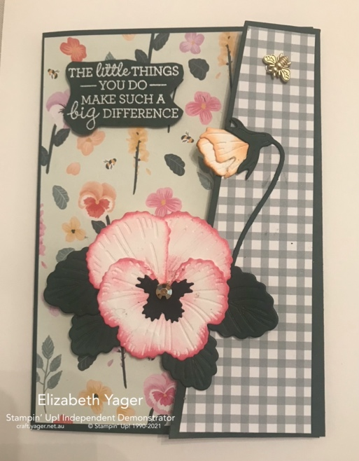
All images © Stampin’ Up!®

Acknowledgement: This card was inspired by Erica Edney

Supplies:

- Stamp Set(s): Pansy Patch - 154999
- Card Stock: Evening Evergreen -155575; Basic White – 159228; Soft Succulent – 155777; Basic Black - 121688
- Designer Series Paper: Pansy Petals - 155807
- Stamp Pad(s) and Ink(s): Polished Pink – 155712; Pale Papaya – 155670; Cinnamon Cider – 153114; Versamark – 102283; White embossing powder - 155554
- Dies and Embossing Folder(s): Pansy Dies – 155680; Beautiful Trees small rectangular die – 155840; Layering Circles – 151770
- Embellishments: Gilded Gems – 152478 (largest gem); Bumblebee trinket - 155568
- Tools: Bone folder – 102300; Paper Trimmer – 152392; Paper snips – 103579; Stampin cut and emboss machine – 149653
- Adhesives – Multipurpose glue – 110755; Mini Dimensionals – 144108; Mini Glue Dots - 103683

Measurements:

- Evening Evergreen Base - 26.5cm X 14.9cm
- Basic White insert – 14.4cm X 10cm
- Pansy Design Designer Series Paper – 14.4cm X 10cm
- Pale green gingham pansy designer paper – 14.4cm X 10cm
- Assorted scraps of Basic White, Evening Evergreen, Soft Succulent and Basic Black for die cuts.

Instructions:

Making pansies for front of card.
- Diecut large pansy pieces in Basic White (2 smaller top petals for top of flower and 1 larger piece for lower part of flower) and two parts of pansy bud also in Basic White. Cut centre part of flower in Basic Black and 2 large, 2 small leaves and stem in Evening Evergreen. Also cut 2 leaves in soft succulent and a pansy out of the large pansy flower designer series paper for inside of card.
- Using a dauber, touch the edge of the flower petals and centre of large pansy with Polished Pink ink. Use dauber and Pale Papaya ink for the bud. You can also use a little bit of Cinnamon Cider ink of the lower part of the bud to give it more definition.
- Using Multi Purpose glue, make up pansies. You only need a dot of glue at the centre part of the petals. Glue Evening Evergreen leaves behind large flower. Glue bud together and add stem to bud.
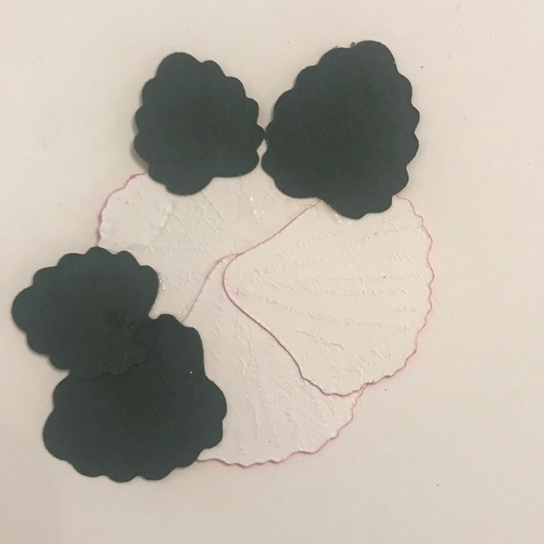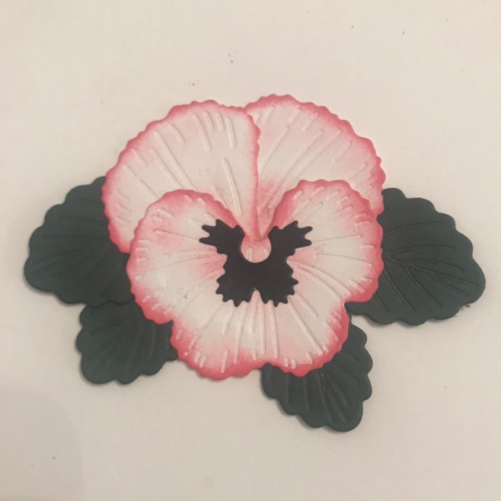
- Cut 2 circles in Evening Evergreen – one about 5.5cm and one 2.5 cm in diameter. This will be for the pansy sliding flower.
- Glue Pansy flower and petals in place on smaller circle.

Making card
- Cut Evening Evergreen 14.9cm X 26.5cm. Score at 10.4cm and 21 cm and burnish. Cut Pansy Petals DSP 14.3cm X 10cm and Green Gingham DSP from same pack 14.3cm X 5cm and large pansy flower as well.
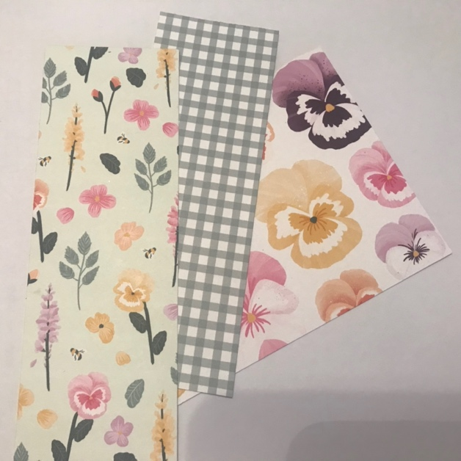

- Adhere larger piece of Pansy Petals DSP to left hand side of front of card. Using small rectangular die from Beautiful Trees, line up the bottom of the rectangle 4 cm from the bottom of the left side of card. Washi tape to keep in place while you die cut. Cut out rectangle through both layers.
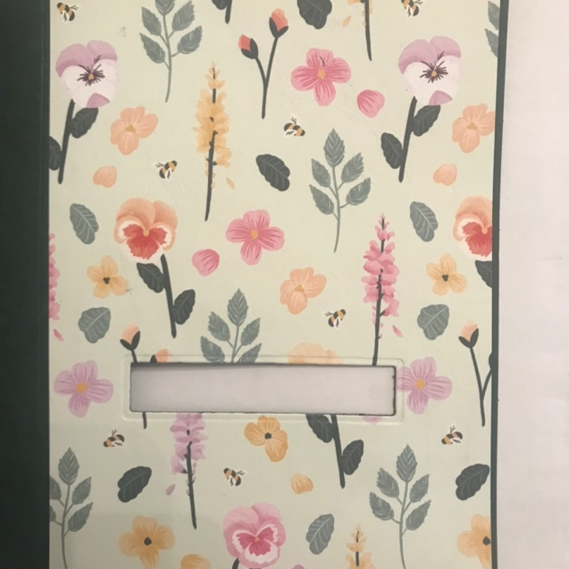

- Right Side flap: Fold over the top of the left hand front of card and line up bottom of rectangular die again 4cm from bottom of card and directly on top of the previous cut. Washi tape to left side and open up and die cut the right side.
- Measure 3 cm in from top of left hand side of card and cut left hand flap at an angle. This flap should be 3cm wide at the top and 5.5cm at the bottom.

- Measure gingham paper 2.5 from right side and also cut at an angle. The top should be 2.5 and the bottom 5cm. Glue this on the right side of card. Cut out the piece of Designer series paper that covers the diecut you made previously. Both openings should line up on top of each other when the card is closed.
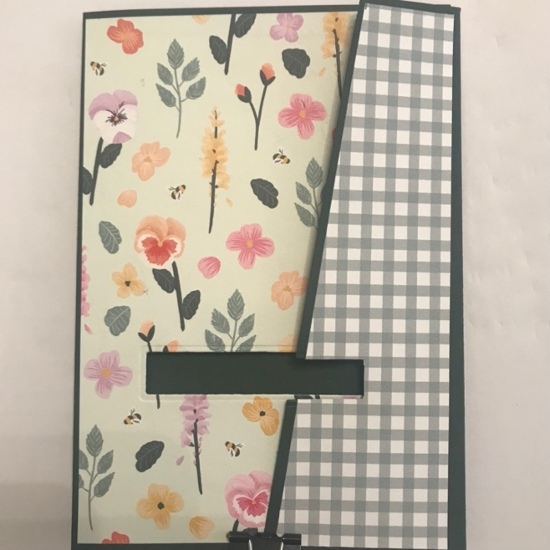
- Place larger circle behind rectangular opening with edge of circle nearest the right hand side of the opening. Place two mini dimensionals on this right side in the space provided by the rectangle. Attach Pansy to this. This acts as your slider. As you move it from right to left, you may have to rotate it a little to get right flap under the flower. Add the bud and stem to the right hand side flap just above the diecut.
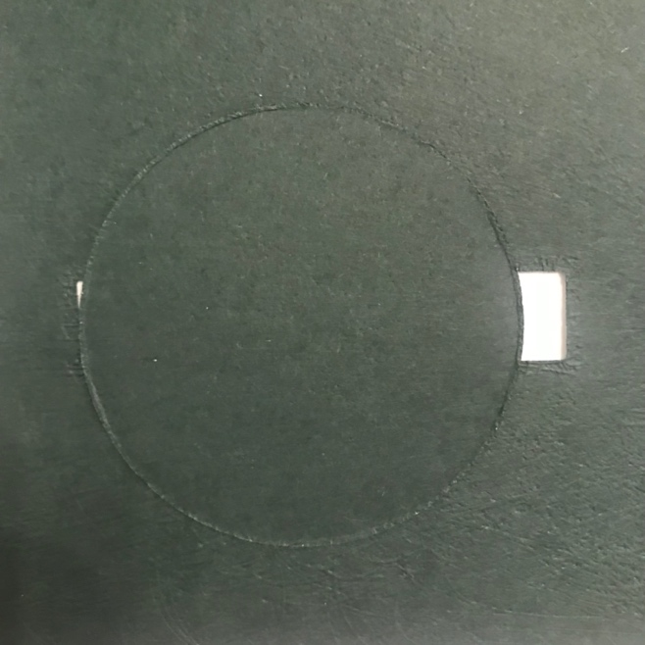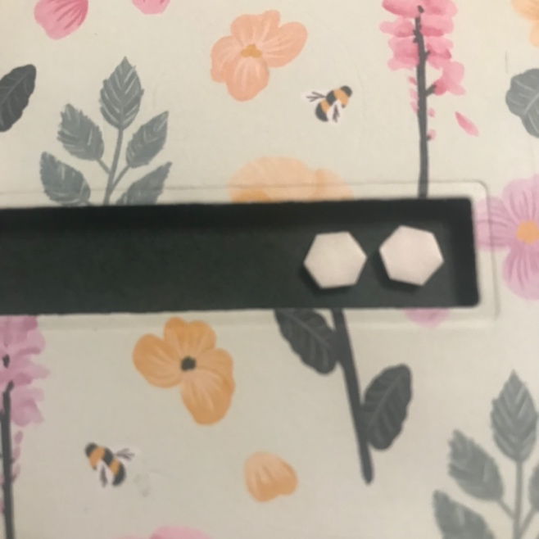
- Add Diecut large pansy and Soft Succulent leaves to inside Basic white layer.
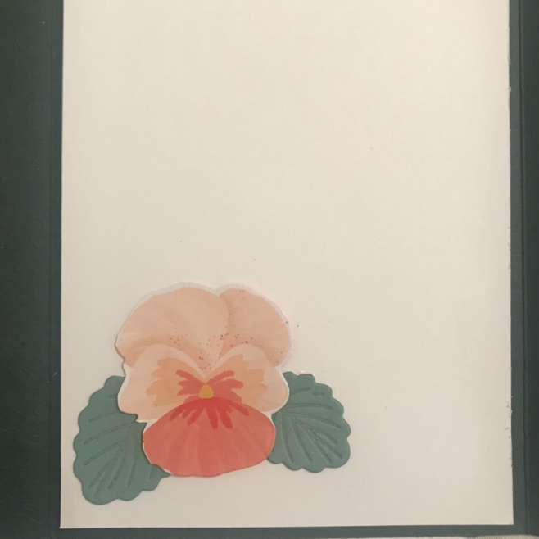
- For sentiment, stamp in Versamark and heat emboss in white embossing powder. For added character, I trace around the stamp on top of the embossing and cut it out in the shape of the stamp. Add with dimensionals to top right hand side of card and add Bumblebee trinket to the left hand side.

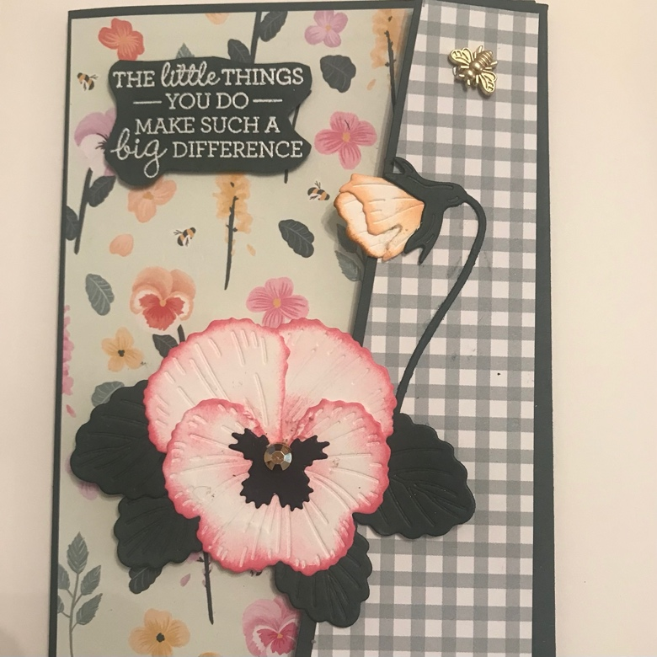

This sheet is provided for you by:

Elizabeth Yager, Independent Demonstrator, Stampin’ Up!, Title: Silver
Contact: elizabeth@yager.net.au

For additional ideas and inspiration, visit my blog at https://craft.yager.net.au

Note: I am part of a group of leaders that have worked together to create these project sheets with one another. We have done this so we can share a variety of project sheets to our team members and customers. We hope you are enjoying these creative cards.

